**Moving Files from Source Folder to Destination Folder**

**Task**

The aim is to automate the process of moving files from the source folder to the destination folder.

**Steps To Automate**

Follow the below steps to achieve the aim:

* Assign the source directory to a variable.
* Count the number of files to be moved by using a ***Counter*** variable.
* Mention the Destination path in the ***Move file*** activity.
* For each item in the source path, use the counter variable to move the files to the destination path.

**Solution**

**Step 1:** Create the variables ***NumberOfFiles***, ***sourcepath*** and ***Counter***. Now, assign the default value of ***sourcepath variable*** to the ***Path of Source Directory***. Refer below.

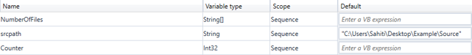**Step 2:** Drag the **Assign** **activity** and assign the **To** section to ***NumberOfFiles*** and the **value** section to ***directory.GetFiles(sourcepath)*** function. This would take all the files from the source path.

**Step 3:** Output the number of files to be moved in the message box. To do that, drag the **Message Box** activity and mention ***NumberOfFiles.Count.ToString+” Files to be Moved”***. This will count the number of files in the source folder and will Print the output as x Files to be moved. Refer below.

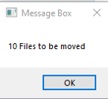**Step 4:** Create a ***Counter variable*** and then drag an **assign activity**. Now, in the assign activity, assign the To section to the Counter variable and the value section to 0. This will assign the count to 0. Your sequence should look like below till now.

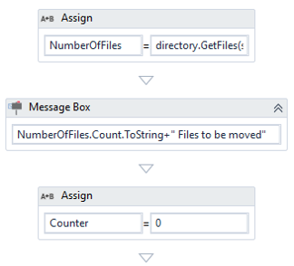**Step 5:** Now, drag the **For Each activity** and mention for each item in **NumberOfFiles,** you have to move the file to the Destination path. To do so, follow the below steps:

**Step 5.1:** In the **Body** section of this activity, drag the **Move File activity**, and mention the ***Destination path*** in the **Destination** section of **Properties Pane**.

**Step 5.2:** Go to the ***properties section*** of **For Each activity** and in the **Type Argument** mention ***String***. Refer to the snapshot below.

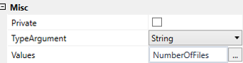**Step 5.3:** To move all the files from the source folder to the destination folder, drag the **assign activity** and assign the **To** value to ***Counter variable***and the **value** section to ***Counter + 1.*** Refer below.

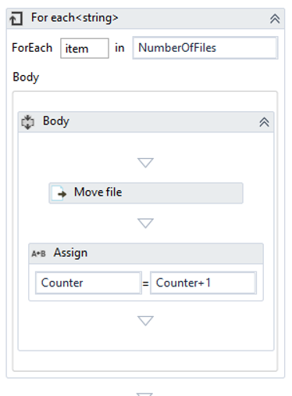

**Step 6:** Execute this sequence by clicking on the **Run** button. You would see that all the files from the source folder would be moved to the destination folder.